# Studify Admin Dashboard Project Documentation

## Project Overview

This documentation details the development of an administrative dashboard system for Studify, an educational platform similar to Udemy. The project involved fetching data from the Studify API, designing comprehensive dashboards in Power BI, publishing them to Power BI Service, and embedding them within the Studify platform for administrative use.

## Project Architecture

The project follows a comprehensive architecture that connects Studify's API data to Power BI dashboards:

1. **Data Layer**:
   * Studify API endpoints hosting educational platform data
   * Azure SQL database for data storage and management
2. **Analytics Layer**:
   * Power BI Desktop for dashboard development and data modeling
   * Power BI Service for cloud-based dashboard hosting
3. **Presentation Layer**:
   * Embedded dashboards within Studify platform
   * Public sharing for stakeholder access

## Data Sources

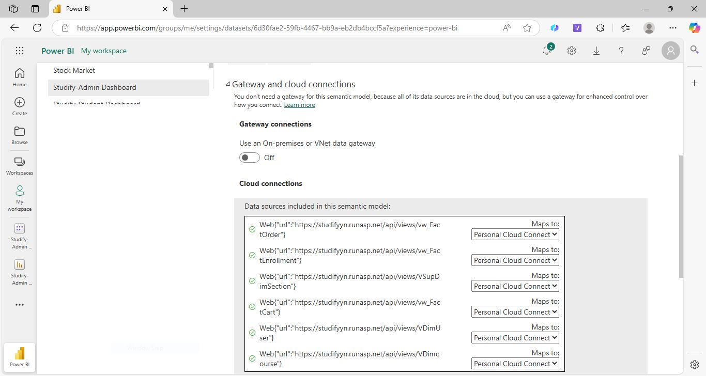

The project utilizes multiple API endpoints from the Studify platform:

https://studifyyn.runasp.net/api/views/vw_FactEnrollment

https://studifyyn.runasp.net/api/views/VSudDimSection

https://studifyyn.runasp.net/api/views/vw_FactCart

https://studifyyn.runasp.net/api/views/VDimUser

https://studifyyn.runasp.net/api/views/VDimCourse

https://studifyyn.runasp.net/api/views/vw_FactOrder

These endpoints provide comprehensive datasets covering:

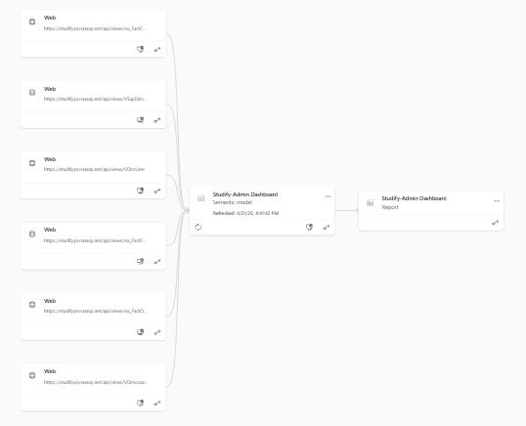

* User enrollment information
* Course catalog details
* Financial transactions
* User profiles
* Course sections
* Shopping cart data

Each data source was configured with "Personal Cloud Connect" authentication to ensure secure data access.

## Dashboard Development

### Data Model Design

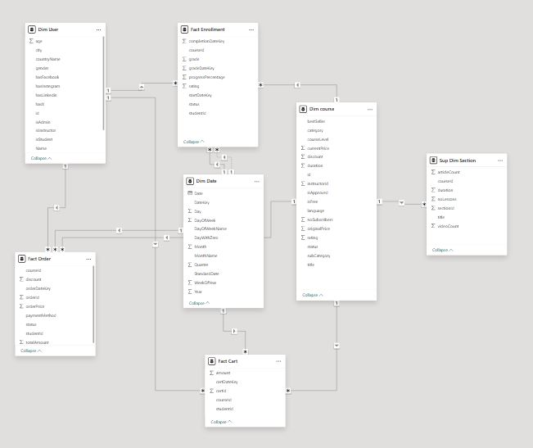

The project implemented a star schema data model with:

* Fact tables: FactEnrollment, FactOrder, FactCart
* Dimension tables: DimUser, DimCourse, DimSection

The entity relationship diagram demonstrates the connections between tables, highlighting the one-to-many relationships that enable comprehensive data analysis.

### Development Process

1. Connected to Studify API endpoints in Power BI Desktop

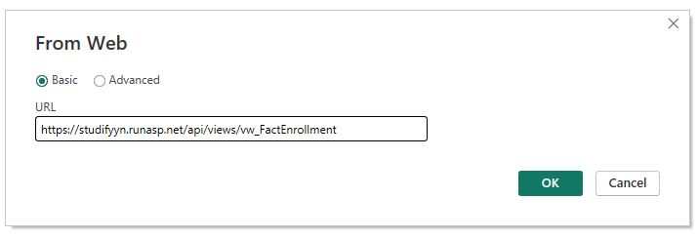

1. Applied appropriate data transformations
2. Created data model relationships
3. Developed visualizations and dashboard pages
4. Implemented filters and interactive elements
5. Added key performance indicators

## Dashboard Pages and Insights

### User Engagement Overview

**Key Metrics:**

* Total Users: 69.5K
* Active Users: 16K
* Engagement Rate: 23.6%
* Average User Rating: 4.0

**Insights:**

* The user base is globally distributed, with the United States (21.3K), China (10.8K), and the United Kingdom (7.5K) leading in volume.
* Active user trends show seasonal peaks, especially around November and December.
* Engagement follows a cyclical pattern, indicating the need for ongoing user reactivation strategies.

**Recommendations:**

* Implement **cohort analysis** to monitor retention trends across user segments.
* Launch re-engagement campaigns during low-activity periods.
* Enhance the user experience based on rating feedback to increase overall engagement.

### Student Dashboard

**Key Metrics:**

* Total Students: 60K
* Average Grade: 76.0
* Average Progress: 56.0
* Total Spent: $1.39M
* Total Savings: $1.41M

**Insights:**

* Strong student presence is observed in North America, Europe, and parts of Asia.
* Learning time fluctuates monthly, showing a recent upward trend.
* 32.19% of students have completed their courses, while 52.19% are currently in progress.

**Recommendations:**

* Develop personalized progress tracking to motivate course completion.
* Set up smart notifications to guide students through their learning path.
* Provide detailed performance reports to help students understand their progress and outcomes.

### Course Performance Dashboard

**Key Metrics:**

* Total Enrollments: 43.3K
* Total Courses: 30.7K
* Completion Rate: 32.2%
* Top Rated Courses: 5.0

**Insights:**

* The Health & Fitness category leads with 13.3K enrollments.
* Completion rates peaked in 2021, followed by stabilization around 40%.
* Underrepresented categories such as Music and Office Products offer growth opportunities.

**Recommendations:**

* Analyze dropout points using **course completion funnels** to improve retention.
* Improve content quality and discoverability in underperforming categories.
* Recommend courses based on learner behavior and preferences.

### Financial Performance Dashboard

**Key Metrics:**

* Total Revenue: $9.5M
* Average Order Value: $248.5
* Total Active Orders: 38.4K
* Cancelled Order Rate: 20.3%

**Insights:**

* Credit/debit cards account for 69.34% of total revenue ($6.7M).
* 78.72% of orders are completed, while 15.80% are cancelled.
* Revenue has steadily increased since mid-2024.

**Recommendations:**

* Expand payment methods by integrating digital wallets or installment options.
* Investigate the reasons behind order cancellations to optimize the checkout experience.
* Add **forecasting visuals** to anticipate future revenue trends.

### Courses Overview Dashboard

**Key Metrics:**

* Course counts and ratings by subcategory
* Student distribution by free vs. paid courses (Free: 43.91K, Paid: 18.37K)
* Students by course level
* Student count and average grade by gender

**Insights:**

* Web Design has the highest number of courses (66.6K), but not the highest ratings.
* Fitness courses receive the highest average ratings (4.01).
* Beginner-level courses dominate (58.51% of all offerings).
* Grade averages between male and female students are nearly identical.

**Recommendations:**

* Improve content quality for popular but low-rated subcategories.
* Diversify course offerings with more intermediate and advanced content.
* Provide personalized course recommendations based on skill level and learning behavior.

### Instructor Dashboard

**Key Metrics:**

* Total Courses: 31K
* Free Courses: 23K
* Total Instructors: 9,536

**Insights:**

* Instructor presence is concentrated in North America, Europe, and Asia.
* Top instructors (e.g., Chris Croft, MTF) produce significantly more courses.
* "The Complete Python Bootcamp" leads with the highest number of subscribers (53K).
* Business, Development, and IT are the most instructor-attractive categories.

**Recommendations:**

* Provide performance reports and benchmarks for instructors to drive content quality.
* Offer incentives for instructors to create content in underserved categories.
* Highlight top-performing instructors and promote best practices.

## Azure Database Integration

The project's data architecture includes an Azure SQL Database backend that:

1. Stores historical data from the Studify platform
2. Enables more complex query operations
3. Provides a reliable data source for Power BI refreshes
4. Ensures data consistency across dashboard views

The Azure database configuration was optimized for performance when handling the large datasets from Studify's operational systems.

## Power BI Service Deployment

The deployment process to Power BI Service included:

1. Publishing the PBIX file to Power BI Service

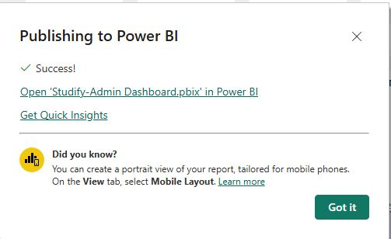

1. Configuring dataset refresh schedules
2. Setting appropriate access permissions
3. Creating a workspace for the Studify dashboards
4. Testing dashboard functionality in the cloud environment

The dashboards were published under "My workspace" with active status and properly mapped data connections.

## Embedded Analytics Implementation

To integrate the dashboards within the Studify platform:

1. Generated embed codes from Power BI Service
2. Configured public access for authenticated embedding

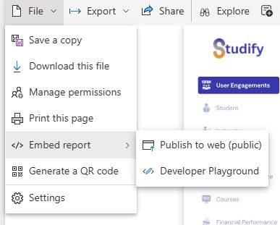

1. Implemented iframe integration within Studify's admin interfaces
2. Set appropriate sizing (600 x 373.5 px) for responsive display

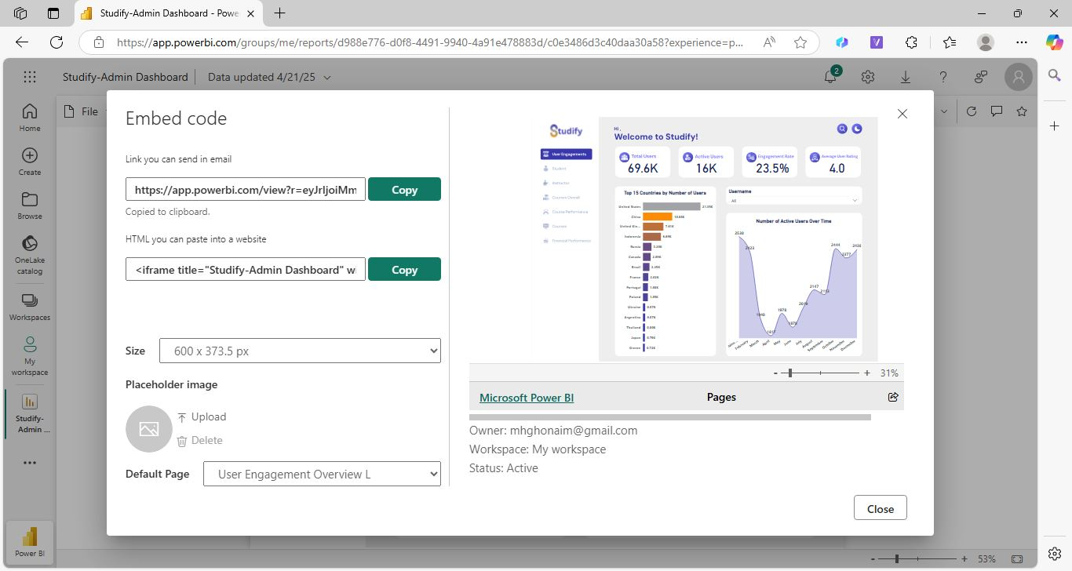

1. Tested embedded functionality across devices

The embed implementation enables Studify administrators to access analytics directly within their platform interface without switching contexts.

## Refresh Configuration

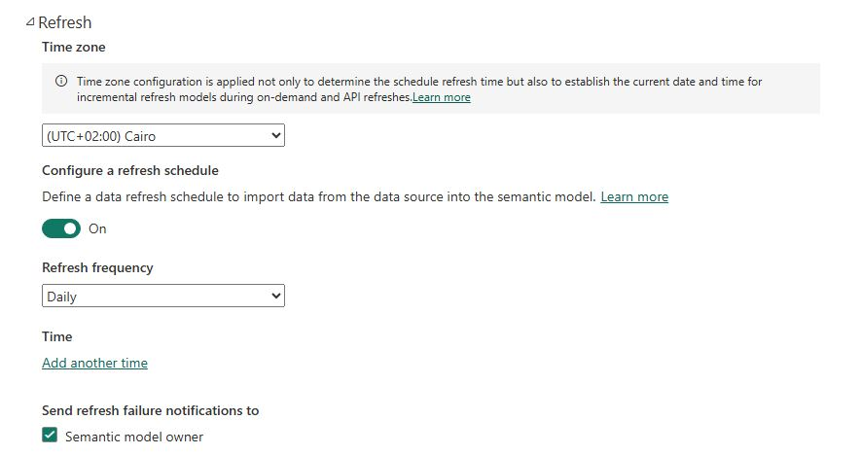

Data refresh was configured with:

* Time Zone: (UTC+02:00) Cairo
* Refresh Frequency: Daily
* Notifications: Enabled for semantic model owner
* Automatic refresh on publish

This configuration ensures that administrators always have access to current data while minimizing API load during peak usage hours.